Spanish Riding School Bereiter Herbert Seiberl Shines the Light of the SRS on Michigan in January
By Jorie Sligh, Clinic Organizer

Winters in Michigan can be long, grey, and bitterly cold. We never know when we might be hit with sub-zero temps, gale winds, and blizzards that make travel all but impossible.

So the last thing a clinic organizer wants to do is schedule a January dressage clinic in Michigan, especially when the clinician is flying across the Atlantic Ocean and many of the clinic riders have to haul their horses to the clinic venue, right?

We-ell, yes and no.

We Want Herbert!

When the clinician is Herbert Seiberl from the Spanish Riding School, the rules change. Bereiter Seiberl can only come to the U.S. twice a year – January being one of those times.

Herbert previously has taught Michigan clinics in January 2007, and two separate Michigan clinics in July 2007. His clear, com-prehensive instructing and patient, encouraging style have built up a dedicated following of dressage enthusiasts in the Midwest.

So those of us who had ridden with Herbert in the past, and the new riders who looked forward to learning from him during his January 2008 clinics, collectively kept fingers crossed that the weather wouldn’t be too terrible and got ready to strap in should bad weather have shown up in the forecast during Clinic Week.

Blue Water Dressage Stable in Bridgeport, MI was the venue for the January 2008 Seiberl clinic, and owners Pam and Bud Atkinson generously offered free stabling if bad weather forced any of the clinic riders to haul in early or stay late due to inclement weather.

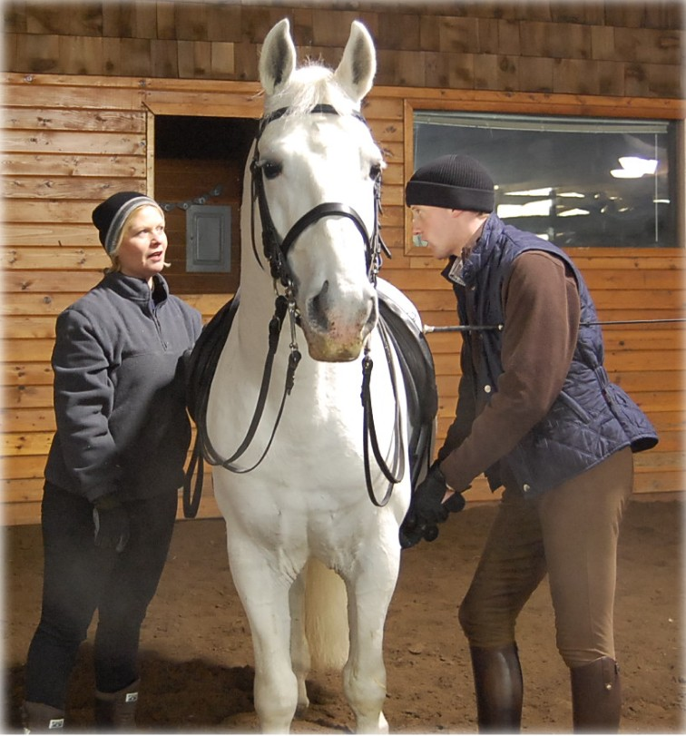

Pam Atkinson and Herbert making adjustments prior to Herbert’s ride on Pam’s stallion, Pluto II Samara

Fortunately, Mother Nature smiled kindly on us again this year, and aside from some lovely fluffy snow on the second day of the clinic, the temps stayed reasonable and the snowfall manageable.

Seiberl Happy with Progress

Many of the riders had ridden with Herbert in one of his previous three Michigan clinics, and Herbert com-mented to me that he really enjoyed seeing the progress in every horse and rider he’d taught before.
“No problem! It’s okay, that’s no problem!”

The riders saw this, too. Jeannie Talarico, who rode with Herbert in July ’07 said, “What impressed me most was the amazing trans-formation in each horse after schooling with Herbert. Even with a wide variety of breeds and issues, we saw significant progress with each horse as well as the riders.”

Ivan Maystead echoed this sentiment. “The horse I took to this clinic was such a different horse than when he was there the first time. He is so much more relaxed. Herbert was able to give us tools to use in the interim so that we could continue to progress.”

Ivan’s wife Suzy agreed.

“My horse is not always dependable in new situations and Herbert was so patient with us. It was such a good experience for him, he seems like he has grown up a lot since he's been home. Herbert makes it so easy to learn. He explains things in such a way that it is easy to concentrate and get what you want from your horse. You even forget the crowd is there. Although Delta never quite forgets, he was much better about going by the audience and listening to his rider.”
Bereiter Seiberl & his stallion Favory Plutona, showing work on the Long Rein in Rotterdam during the 2008 SRS European tour
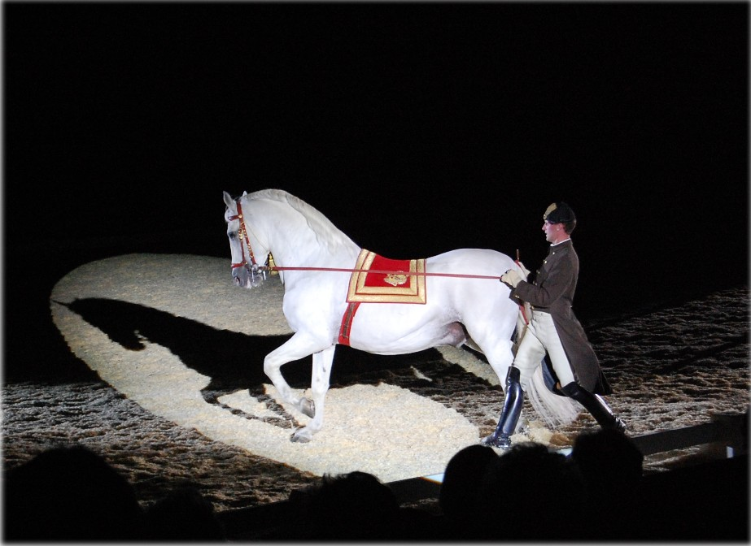

Riders taking lessons from Herbert for the first time were also enthusiastic about their lessons.

“A Fan Forever”

For Brenda Aloff, this clinic was the first time she and her Morgan gelding Topper worked with Herbert.

Said Brenda, “Herbert is clearly a craftsman; I ex-pected that. But I was not prepared for how good Herbert proved to be with showing me and com-municating to me what he wanted me to do, to the extent that he would come over and show me exactly how I should use my reins, legs and weight.

“When he took the reins and had me be ‘the horse’s mouth’ and then showed me the exact timing of the half-halts to the halt, it was indescribable. By changing my timing by a half-a-second, suddenly my halts improved drastically.

“The event that made me swoon and a fan of Herbert’s forever was one of the times when he was standing in front of Topper and showing me exactly the rein aids he wanted me to use. As he was doing this, Topper lifted his head up and nuzzled Herbert’s face. Quite naturally, Herbert laughed and gave Topper a smooch on the nose, and then, without missing a beat, he went right back to instructing me.

“If there was ever a moment that defined how much this man loves his work and the horses he works with, for me, this was it.”

“Riding is very easy when you are really clear with your aids”

In this clinic I rode Pam Atkinson’s retired Grand Prix gelding, Brandenberg. He’s a wonderful horse, but his imperfections also taught me important lessons.
As Alois Podhajsky (Director of the SRS, 1939 – 1965) said, “I must not forget to thank the difficult horses…who were better teachers than the well-behaved horses who raised no problems.”

Although not as fit and tuned as in his younger days when he was showing, Branden’s not exactly difficult, but I understand what Podhajsky means.
Branden isn’t naturally forward and will happily lean on the bit and brace his neck. It takes constant diligence on my part to keep him forward, light, and my fingers closed so he doesn’t sneak the reins out of them.

Herbert taught me how to use transitions to keep him light, round, and off of his forehand. Walk, trot, walk, trot, walk, halt, trot, halt… It sounds so easy, but the key was making sure that the transitions were performed frequently and correctly: Prepare with half-halt, half-halt, breathe out, no pulling!

The few other upper level horses I’ve ridden were forward and light, so I didn’t appreciate the importance of transitions and doing them just so until I had to use them so frequently and precisely with Branden.
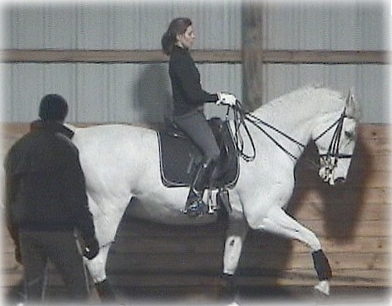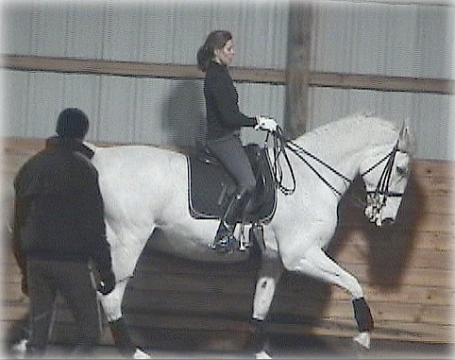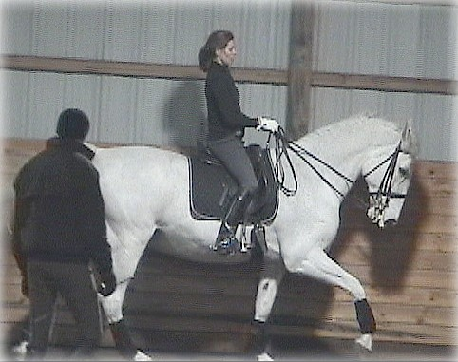
“It’s okay. You have time.”

Branden is also a great teacher because he’s so sensitive and well-trained. When the aids are correct, he will do tempis, passage and piaffe, half-pass, etc. He’s so good at tempis that he really helped me to get my timing down – threes, twos, and ones are no problem when my aids are correct.

And if my aids are a little unclear… well, he lets me (and Herbert and the audience!) know it.

I’d gotten sloppy with my legs, especially my outside leg, and getting away with it since my horse is not yet trained to a high enough level that he’s as sensitive as Branden.

In canter, I was unknowingly slightly pushing with my outside leg for forward, which caused lead changes due to the changing of pressure against his side. And if I let my inside leg slip backward…well, Branden happily began doing one tempis, just to make it clear that I was being unsteady again!

While working on tempis, the importance of clarity and timing was very apparent.
Branden & Herbert teaching me the importance of accurate and clear aids, esp at the canter!

Threes and twos were fine, but I struggled with the ones. My aids were too slow when I got him started, and we kept doing twos.

When we finally got the ones, Herbert smiled and said, “Riding is very easy when you are really clear with your aids.”

It opened my eyes (again – I’d learned a version of this in the July clinic!) as to just how important it is to be clear and consistent with aids.

“Herbert is FAIR!”

It was wonderful to see how many auditors turned out to watch and learn from Herbert.

Auditor Kate Capek, who drove over four hours from Indiana, said, “One thing that really struck me was both his sense of fairness to the horse and his ability to articulate HOW the rider is to be fair. One subject he brought up repeatedly was that the rider's posture gives the horse (for good or ill) something to mimic.”

Auditor PK Harrison said, “The clinic was wonderful. I learned so much. I was an auditor for the full three days and I learned something new EVERY day.

“I love that Herbert is so quiet and always has the horse's development, proper and classic development, at the forefront of his instruction. That it's always "no problem" and you know, that it will be NO PROBLEM.

“All of the horses improved so much. They were rounder, more correct and happy in their work. The riders sharing what they learned and allowing the auditors to ask questions was much appreciated. We’ll be back!”

Relaxing at the Reception

A wonderful treat for the riders and auditors was the lovely reception immediately following the clinic on Sunday, held at Bud and Pam’s spacious home at Blue Water.

Janis Cliff, one of Pam’s students, is an amazing cook and party planner, and with the help of Pam’s sister, Penny Kellar, provided a fantastic buffet of delicious food.
Penny Kellar, Janis Cliff, and Pam
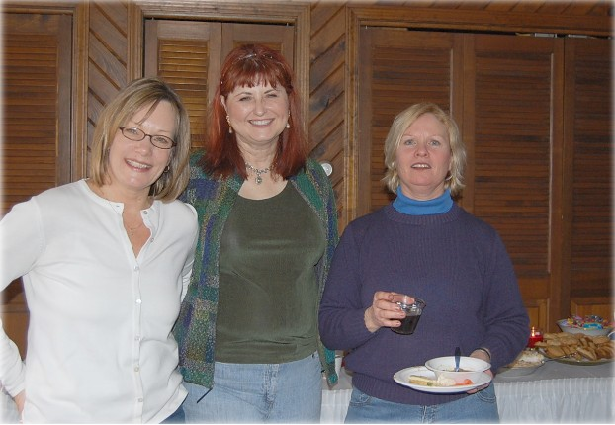
Atkinson at Sunday’s reception

It was a relaxing chance for
everyone to talk with Herbert, ask questions, and
get to know him and one
another better, while enjoying delicious cookies, cake, fruit, stew, and the best coconut
cream pie I’ve had in my life.

In addition, Pam surprised the attendees with door prizes of a saddle pad, equestrian-themed coasters, and a lesson on her Grand Prix horse, Brandenberg.

Many thanks to Pam, Bud, Janis, and Penny for arranging this special event, and to the riders and auditors who were able to be part of it.

Until Next Time…

In the weeks following the clinic, Michigan received steady snowstorms and cold temperatures, a reminder that once again, we were lucky with our January clinic weather. This has been a ferocious winter.

The clinic with Herbert was like a breath of fresh air and sunshine in the middle of our hard winter, in terms of the education and motivation he gave to those attending.

Thank you, Herbert, for coming to Michigan to share your gift for teaching the classical, timeless method of riding practiced by the Spanish Riding School for over 430 years.

We look forward to Herbert’s return in the summer and hope he continues to be delighted with the progress made in the meantime, thanks to his instruction and en-couragement.

Bereiter Seiberl will be in Michigan in July 2008. Dates will be posted on www.dressageclinics.org, or contact Jorie at jorie@dressageclinics.org to be added to the SRS Clinic list. For information on riding in or auditing clinics with SRS Bereiters, or hosting an SRS clinic outside of Michigan, please contact Jorie at jorie@dressageclinics.org.

All photos taken by Jorie Sligh, except for the photo of Herbert, Jorie, and Branden taken by Sue Ennis. Article copyright 2008 and may not be reprinted without permission.

